AOM 2012C: Types and Systems of Agricultural Operations
Valencia College West

Instructor: Dr. Denise DeBusk
Phone: (407) 582-5100
Email: ddebusk@valenciacollege.edu or through Canvas email
Student Engagement Hours:
- Monday-Wednesday 9:30am-12:30pm (online)
- Thursday 12-1:30pm (on campus)
- Friday 1-2:30pm (online)
Modality: Mixed-mode
Class Days/Times: Fridays, 10am-12pm
Location: West, 1-228 (first and last class session); at field trip location for other sessions
Credit Hours: 3
Prerequisites: This course does not require any prerequisites.

Welcome to the Course!
An agricultural system includes many components that interact and operate within a certain boundary to achieve a specified agricultural objective on behalf of the beneficiaries of the system. These systems can include farming or fruit production, organic production, or nursery or greenhouse production. They focus on a unique set of practices, management techniques, and sometimes philosophies, focusing on the production of a commodity. This course will explore various types of production by highlighting on local companies and their practices. It will also highlight the business aspects that are involved in running a business, culminating in the creation of a business plan and analysis of a current business.

Course Information

Course Description
This course involves the study of operational and management styles utilized in agricultural (horticultural) situations. Emphasis on process of systems development, administrative definition, product research and development, service and maintenance, machinery and equipment needs and application, operational analysis for purchasing, communications, transportation, production, and marketing. Lab experiences will include field trips to horticulture concerns for systems analysis.

Course Outcomes
There are several broad learning goals we will help you achieve by the end of this course. Specifically, you will:
- Analyze the growing methods in a variety of agricultural facilities.
- Describe the business aspects of an agricultural operation.
- Create a business plan.
- Discuss current topics in the agricultural industry.
- Demonstrate employability skills.

Textbooks (optional)
The following book will be used for the business start-up lectures. It is optional, but highly recommended if you plan on starting your own business.
- Stephenson, G. (2019). Whole Farm Management: From Start-Up to Sustainability. Storey Publishing, LLC. 312 pages.

Valencia College Core Competencies
This course seeks to reinforce the following Valencia Student Competencies: Think clearly, critically and creatively by analyzing, synthesizing, integrating and evaluating symbolic works and truth claims. Reflect on your own and others’ values from individual, cultural and global perspectives. Communicate by reading, listening, writing and speaking effectively. Act purposefully, reflectively and responsibly by implementing effective problem solving and decision making strategies.

Our Inclusive Learning Environment
Your success in this class is important to me. We all learn differently and bring different strengths and needs to the class. We expect everyone in this class to contribute to a respectful, welcoming, and inclusive environment to support the learning of all other members of the class. If there are aspects of the instruction or design of this course that result in barriers to your inclusion or accurate assessment or achievement, please let me know as soon as possible.
If you have a disability and require accommodations, please let me know during the first two weeks of the semester. You will need to register with the Office for Students with Disabilities (OSD) (West Campus SSB 102, 407-582-1523). OSD determines accommodations based on appropriate documentation of disabilities and provides a letter to me with them.

What to Expect in this Class?

Teacher Expectations
I believe that anyone can succeed in the class if the right learning environment and strategies are used. I have structured this course to provide a variety of learning assessments with diverse learners in mind. I value your uniqueness and experience and want you to value your classmates as well. We are all learning together so please reach out to me if you have any questions or need extra assistance. I am here to help you learn.
- I will follow the course outline as closely as possible and will notify you of modifications in the outline if they happen.
- I will attempt to create and maintain an online atmosphere in which you feel free to both read others’ views and express your own views, as well as ask questions to increase your learning.
- Please email me about anything that you are unclear. I tend to respond quickly and I want to be supportive of your learning and growth.
- I will posts grades to the Canvas Gradebook and provide feedback within a week (7 days) for a submitted assignment.

Student Expectations
Set goals for yourself for this course and plan/work to meet them. Meet all course deadlines and you will receive feedback within a week on the submitted assignment. Value your classmate’s opinions and be open to learn new ways of thinking. Complete all assignments and quizzes without sharing/copying other’s work or answers and be proud of your work.
- Please inform me by phone or e-mail if you will miss class and why and get notes and other class information from a fellow student. I recommend exchanging phone numbers with your tablemates.
- You are expected to check your Atlas email and Canvas inbox on a regular basis throughout the week.
- Since this is an online class, all of it is spent at the comfort of a computer; you can expect to devote 3-6 hours each week to this course.
- Feel free to share feedback regarding how well the class is meeting your needs or if material is unclear. I make changes to the class based on feedback, either on the spot or in the future.
- It is also expected that you will treat classmates with respect and observe the rules of confidentiality regarding personal information shared in class.

How your Learning will be Assessed?
Turn in all assignments according to the schedule outlined on Canvas.
Video Guides/Activities: You will complete video guide questions about the field trips or details about the parts of a business start-up. You also complete a resume and roundtable reflection.
Discussions: There will be discussions on hot topics in the agricultural industry and parts of the business. You will need to reply to two of your peers.
Quizzes: To reinforce the concepts you have learned each week, you will complete quizzes by the Thursday of the following week. Quizzes will be based on the videos and discussion topics. Questions may include multiple-choice, matching, and true/false. You will have one opportunity to take the quiz. You need to download Respondus Lockdown Browser to take the quizzes and you will have 15 minutes to do 10 questions.
Projects: You will complete two projects in the class.
- Company Profile: You will choose a company that you would either like to work for or want to learn more about it. You will include aspects such as the history, products, sales, and financials of the company. You will create a PowerPoint and share it on a discussion board. You will reply to peers on how your company differs from theirs.
- Business Plan: You will submit a business plan for a business that you would be interested in creating. It will include parts such as a vision and mission, market research, operations plan, personnel plan, and financial plan. Many of the business-related discussions will break down the components of the project.
Extra Credit: You can get extra credit for attending and writing a report for the optional field trips. You can also get extra credit for completing your Student Feedback at the end of the semester.
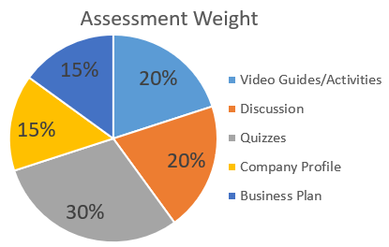
Late Work/Makeup Policy: Since life sometimes gets in the way, I drop the lowest quiz score and there is a two-week grace period after assignments are due. During this time, late work is eligible for partial credit (2% deduction per day). If there are extenuating circumstances, please contact me as early as possible to discuss your options.

Grading Scale
A = 89.5-100%, B = 79.5-89.49%, C = 69.5-79.49%, D = 59.5-69.49%, F = below 59.5%
Your grade will be calculated as follows:
- Video Guides/Activities – 15%
- Discussions – 15%
- Quizzes (lowest score dropped) – 30%
- Projects (2) – 15% each
- Participation (permitted 1 excused absence) – 10%

TENTATIVE COURSE SCHEDULE

Date | Topic | Wednesday Assignments | Friday Activities | Sunday Assignments
Jan 8-14 | Orientation |  | Orientation  Intro to Farmers  Intro to ChatGPT | Orientation Quiz  Be in the Know Assignment  Discussion: Introductions
Jan 15-21 | Business Management: Dream It | Quiz: Whole Farm Management and Farmer Profiles | No Class | Video Guide: Dream It  Discussion: Mission Statement, Vision, & Goals
Jan 22-28 | Unique Alternative Crops and Methods | Quiz: Dream It | Field Trip: Monterey Mushroom | Video Guide: Monterey Mushroom Field Trip  Discussion: Alternative Crops and Methods
Jan 29-Feb 4 | Business Management: Do It | Quiz: Alternative Crops | No Class | Video Guide: Do It  Discussion: Designing your Business
Feb 5-11 | Career Preparation | Quiz: Do It | No Class | Activity: Roundtable Reflection Discussion: Job Interview Questions
Feb 12-18 | Large-Scale Production | Activity: Resume | Field Trip: Cherry Lake Tree Farm | Video Guide: Cherry Lake Field Trip  Discussion: Agriculture Labor
Feb 19-25 | Business Management: Sell It | Quiz: Large-Scale Production | No Class | Video Guide: Sell It  Discussion: Marketing your Business
Feb 26-Mar 3 | Agritourism | Quiz: Sell It | Field Trip: Lukas Nursery | Video Guide: Lukas Nursery Virtual Field Trip  Discussion: Value Added Agriculture
Mar 4-10 | Business Management: Manage It | Quiz: Agritourism | No Class | Video Guide: Manage It  Discussion: Finances in your Business
Mar 11-17 | Company Profile | Quiz: Manage It | No Class | Project: Company Profile
Mar 18-24 | Spring Break
Mar 25-Mar 31 | Permaculture |  | Field Trip: Fox Valley Farm | Video Guide: Fox Valley Farm Field Trip  Discussion: Permaculture
Apr 1-7 | Business Management: Keep It | Quiz: Permaculture | No Class | Video Guide: Keep It  Discussion: Business Structure and Regulations for your Business
Apr 8-14 | Diversification | Quiz: Keep It | Field Trip: Lakeridge Winery | Lakeridge Winery Field Trip Report (extra credit)  Discussion: Diversifying your Industry
Apr 15-21 | Business Plan |  | Shark Tank Business Presentations | Project: Business Plan
Apr 22-24 | Business Plan (late days)

Friday Class Sessions/Field Trips
- Jan 12 – Orientation
- Jan 26 – Monterrey Mushroom Field Trip
- Feb 16 – Cherry Lake Tree Farm Field Trip
- Mar 1 – Lukas Nursery Field Trip
- Mar 29 – Fox Valley Farm Field Trip
- Apr 12 – Lakeridge Winery Field Trip
- Apr 19 – Shark Tank Business Presentations

Vacations and other important dates
- Jan 8 – Classes begin
- Jan 15 – Martin Luther King Jr Day (no classes)
- Jan 16 – Drop/Refund Deadline
- Feb 9 – Learning Day (no classes)
- Mar 15 – Withdrawal deadline
- Mar 18-24 – Spring Break (no classes)
- Apr 28 – Term ends

How can you Contact Me?
You may contact me in various ways during this semester.
- You may contact me through the Canvas Inbox. This is probably the best and quickest method of communication. I will respond to your message within 48 hours, often much sooner, with the exception of days and times when the college is closed.
- For more complicated issues (e.g. walking you through an assignment, personal issues), your best option is to schedule a Zoom meeting with me.
- You may email me at ddebusk@valenciacollege.edu. In your messages (if not using the Canvas Inbox), please indicate your course number so that I may better assist you.
- If you prefer to speak to me directly, my Valencia phone number is (407) 582-5100, and I will be happy to make an appointment with you.

What Policies are in the Course?
No Show Policy
Since this is an online class, I count attendance as assignments submitted. The Orientation Quiz is the required attendance activity for the first week. You need to complete the activity to show that you are attending the course. If you do not complete that activity by the end of the week, you will be withdrawn from the class as a “no show.” You will still be financially responsible for the class and a final grade of “WN” will appear on your transcript for the course. If you are unable to complete the Orientation Quiz during the first week, notify me as early as possible and we can discuss your options. If you are not planning to continue the class, make an effort to drop the course before the deadline.

Attendance Policy
This is a mixed-mode course managed through Canvas with in-person field trips. You must have access to the Internet to complete the online requirements. I will check your attendance based on your participation in the field trips and submission of coursework. In the event of an extended absence, you should contact me so that we can discuss your options. If you do not submit any assignments or attend the field trips for two weeks, I will email you about your absence. If I do not get an email back within a week explaining your absence, I will withdraw you from the class. If you contact me but do not begin completing work, you will be withdrawn after another week. After the withdraw deadline, students with an absence of more than 2 weeks will receive the final grade that is earned according to the course grading policy.
Withdrawal
The deadline for Drop/Refund is Jan 16th and for Withdrawal is Mar 15th. Per Valencia policy a student who withdraws from class before the established deadline for a particular term will receive a grade of “W. A student is not permitted to withdraw after the withdrawal deadline.
Since I have an attendance policy, I can withdraw you for violation of that policy, but I strive to work with you so that you can complete the class. If you are withdrawn, you will receive a grade of “W”. This can affect you financially and cause problems with any future financial aid you receive. After the withdrawal deadline, I will not withdraw you and you will receive the grade earned at the end of the course. If you withdraw or is withdrawn from a class during a third or subsequent attempt in the same course, you will automatically be assigned a grade of “F.” If you do not intend to complete the course, you must withdraw yourself prior to the withdrawal date. Prior to withdrawing, please reach out to me to discuss your situation.
Academic Integrity
Valencia College is a community of scholars committed to the values of integrity. In this community, all members including faculty, staff, and students alike are responsible for maintaining the highest standards of academic honesty and quality of academic work. As a student and member of the Valencia College community, you are expected to demonstrate integrity in all of your academic endeavors. Unacceptable behavior include cheating, fabrication, plagiarism, using unauthorized study aids, or facilitating academic misconduct. Please review our campus policy on academic integrity.
All work submitted by you is expected to be the result of your individual thoughts, research, and self-expression. Whenever you use ideas, wording, or organization from another source, you need to acknowledge the source appropriately. It is still considered plagiarism if you copy and paste from an online source without paraphrasing the information first, even if providing a reference. Since writing can be difficult, I will provide you resources to assist your efforts. If too much of your work is similar, I will allow a rewrite for up to 50% of the assignment score for the first offense. A second offense will result in a zero score on the assignment and a third offense will result in a class grade of F. Take advantage of the project check-ins to receive feedback on your writing. As an alternative to the 50% rewrite, you can resubmit your work within the grace period with the partial point deduction.

Netiquette
It is important to be aware of your behavior in an online learning environment to ensure positive interactions with your instructor and peers. This requires you to follow some guidelines for behaviors.
All students are expected to:
- Show respect for the instructor and for other students in the course
- Respect the privacy of other students
- Express differences of opinion in a polite and rational way
- Maintain an environment of constructive criticism when commenting on the work of other students
- Remain focused on the learning topics during discussions and activities
College Student Conduct Policy
Valencia is dedicated not only to the advancement of knowledge and learning but also to the development of responsible personal and social conduct. As a registered student, you assume the responsibility for conducting yourself in a manner that contributes positively to Valencia’s learning community and that does not impair, interfere with, or obstruct the orderly conduct, processes, and functions of the college as described in the Student Code of Conduct.

Technology Requirements
Students should verify computer software and hardware requirements to ensure course work can be submitted successfully. Since all assignments are submitted through Canvas (unless otherwise noted), access to a computer is required for this course. You will need to download Respondus Lockdown Browser to access the quizzes and final exam which requires a computer (not an ipad, tablet, or Chromebook). Students can borrow a computer from Valencia for the semester. Canvas lists minimum computer specifications and supported browsers to ensure compatibility. The Chrome browser is recommended. Students are also encouraged to install the Canvas app on their Android phone or iPhone in order to receive mobile notifications and to access your courses via your mobile device.

Third Party Software & FERPA Policy
Valencia College has a firm commitment to protecting the privacy rights of its students. Under no circumstances will your test scores, total points, or final grades be discussed on the telephone or over e-mail. FERPA rights to privacy prevent the divulging of scores or related materials by these means. Scores will only be given face-to-face with each student or by accessing your ATLAS account.

Student Resources for Support and Learning
As a Valencia College student, you may experience challenges such as struggles with academics, finances, or your personal well-being. Valencia College has a multitude of resources available to all students. Many of these resources are listed below and we encourage all students to explore them as needed. If you are experiencing a mental health emergency please contact 9-1-1 or BayCare Behavioral Health at (800) 878-5470.
- Student Assistance Program: Valencia students can get immediate help with issues dealing with stress, anxiety, depression, adjustment difficulties, substance abuse, time management as well as relationship problems dealing with school, home or work. BayCare Behavioral Health Student Assistance Program services are free to all Valencia students and available 24 hours a day by calling (800) 878-5470. Free face-to-face counseling is also available.
- Valencia Counselors: Valencia counselors care about your emotional well-being so they offer both virtual and in-person options to connect with students. Connect to counselors through the student support form.
- Pooky’s Pantry: It is a free resource that offers non-perishable food items, hygiene items, socks, outside resource information, and local housing information. There are locations on each campus.
- Advising: The advisor for the Plant Science and Agricultural Technology program is Heidi Shugg. She can be reached at hshugg1@valenciacollege.edu or 407-582-1461. You can schedule an appointment using her link. She is a great resource for questions about classes, degree programs and certificates, graduation, and transferring to a university.
- Learning Support: Learning Support Services provides students with academic support through distance tutoring, face to face tutoring at the campuses, writing consultations, library services, and resources. Tutoring is offered in most academic disciplines including math, science, foreign languages, English for academic purposes (EAP), computer programming and writing assistance for any course. For more information on how to access tutoring and library research assistance, please visit the college-wide Learning Support Services LibGuide.
- Skillshops: Skillshops are free workshops, or mini courses that provide real-life solutions to common student issues.
- Career Center: Don’t wait until your last year – visit the career center today!
- Library: At each campus library, librarians and other qualified staff can assist students with searching and finding items and information, MLA and APA citations, and technologies. The library provides a variety of books, eBooks, online articles, textbooks, DVDs and streaming videos to support course-related research and other learning needs. View the Library website for more information.

How to Succeed in this Course?
There are many ways for you to show me what and how you are learning, through your effort, interaction and class participation, application of scientific thinking to solve real world problems, and performance on assignments and quizzes. This class has been structured to help all students get the support and guidance needed to succeed in your learning. The below graphic is how the class is structured to best facilitate learning. This class is split between aspects of becoming an employee of a company and creating a business yourself since either is a possibility. The following tips will help you be successful in this class and in other classes throughout your career at Valencia College.
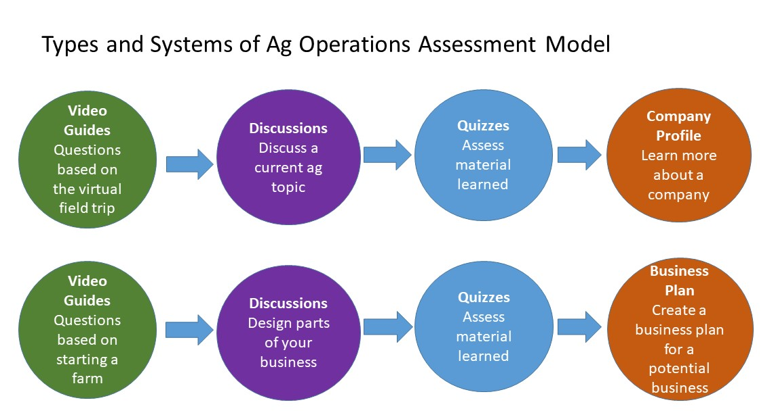
- “LEARNING” IS AN ACTION VERB!! Most students need to do more than just watch lectures and reread their notes. Spend 1-2 hour blocks of time several days a week actively writing or discussing concepts to make them a part of your memory. Use the words you learn often, they will sink in better.
- Check Canvas every other day and change your settings so you are getting the notifications for announcements and submission comments in your email. You don’t want to miss an important announcement or extra credit opportunity.
- Progress through the modules rather than relying on the to-do list on Canvas. The module is set-up to guide you through material and increase mastery of the information.
- Make to-do lists and prioritize tasks. Record all the things you need to accomplish then focus on completing one task at a time. Prioritize your task based on the most critical and time-sensitive ones. You can use paper to-do lists or an app. Don’t forget to reward yourself for a job well done once tasks have been successfully completed.
- Eliminate distractions so your attention is on the task-at-hand. You will finish tasks and move on to the next ones more quickly while paying more attention to details. Turn off the TV, put your phone on silent, and keep your study area organized.
- Take a break. Take a 10-15 minute break each hour or a 5-minute break after every 20 minutes of studying. This will prevent you from burning out too soon and you are more likely to retain the material compared to studying 3 hours straight. Good break options include listening and singing to a song, taking a walk, or getting a snack.
- Ask questions. Make lists of confusing topics from your studying and ask questions (as many as you can!). Talking to your professor helps you as well your professor to refocus on the topic again.

